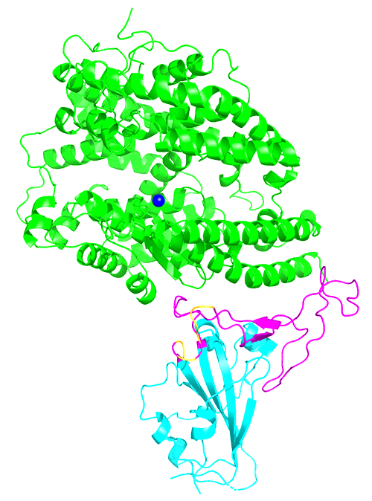 **Flow Chart**

**Aim of the Experiment:** Express **receptor-binding domain (RBD)** in stably transformed rice cell for developing country applications. Comparing level of the RBD protein production of different tissue and different plants individual.

Production of the SARS‐CoV‐2 Receptor

‐binding Domain in stably Transformed

Rice Plants for Developing Country

Applications, Saba-Mayoral A. 2023.

**Notes and Explanation**

**Flow chart**

The sequence of the RBD can be found in NCBI by Gene ID *1489668*, while its full name is ***S spike glycoprotein***. After getting the RBD gene sequence send it to the company to synthesize the fragment

Although we can directly use the original DNA sequence to synthesize, because RBD is spike of SARS-COV-2, its expression location is usually mammalian cells. If we use protein sequences from the database and use the ***reverse translate*** algorithm to obtain the DNA that are more suitable for synthesising in monocotyledonous plant cells, it will match the codon of the host as we use rice for gene expression.

In the process of designing RBD sequence, we insert two different types of promoters before the RBD sequence, which are ubiquitin (Ubi-1) promoter and endosperm-specific barley D-hordein (Hord) promoter. Which means construct two different type of target RBD gene: ***pUbi-RBD*** and ***p-Hord RBD***.

|  |  |  |
| --- | --- | --- |
|  | Ubi promoter | Hord promoter |
| Type | House-keeping gene promoter | Luxury gene promoter  (Expressed in send) |
| Express in | All tissue: Callus, Roots, Flag Leaf, Leaf, Seed coat, Seed | Only in  Callus and Seed |

***Tumour inducing plasmid (TiP)*** of ***Agrobacterium***is chosen as the vector. There are also some other method and medium such as CaMV and PEG which are wildly use in plant genetic transformation.

The Ti plasmid includes the T-DNA region that can integrate the target gene, the Vir region that encodes transfer related proteins, the Con region,and the Ori region that regulates plasmid self-replication. The changes in the ***T-DNA region*** during the modification process are as followed.

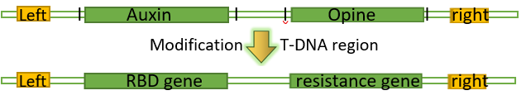

**Step 1:** Construction and Incubation of the Vector Contains RBD Gene

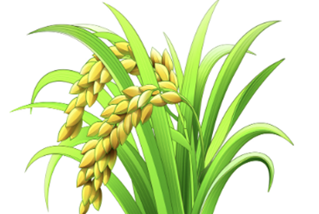

**Synthesize the DNA**

Send the RBD sequence with the restriction site suitable for vector and Ubi or Hord promoter to the company.

**Get the sequence of RBD**

Search the sequence of the RBD in the NCBI database and reverse translate it to the DNA sequence.

s

**Modification of TiP**

Using restriction endo-nucleases to modify TiP. Insert the synthesized RBD gene and antibiotic resistance fragment into plasmids by DNA ligase.

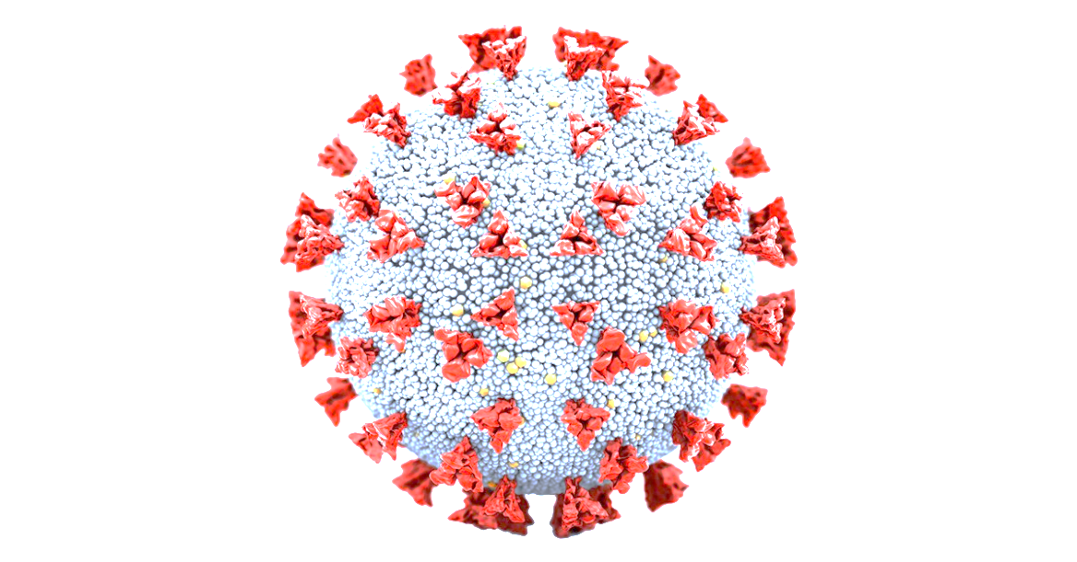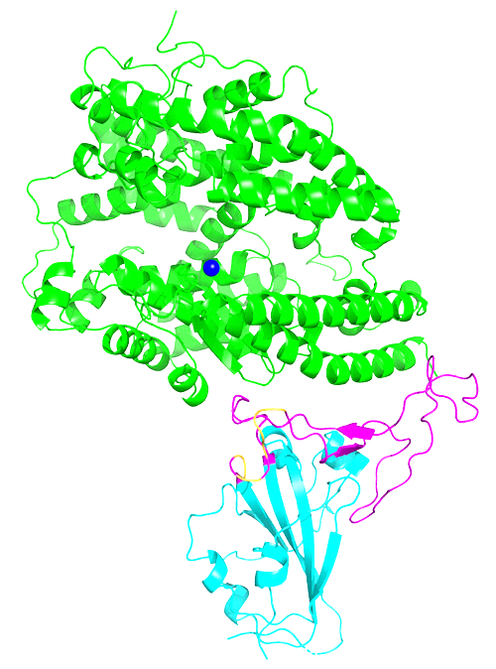

|  |  |  |
| --- | --- | --- |
| Plant line | Lines 9, 19, 16 | Line 8, 12, 24 |
| Promotor | p-Ubi | p-Hord |
| Target Tissue | All tissue: Callus, Roots, Flag Leaf, Leaf, Seed coat, Seed | Callus  Seed |

***Protocol of Purification*** 1.Crush the tissue into suspension, add protease inhibitor buffer, using filtration, centrifugation and solvent dissolution to remove magazines. 2. Loading protein solution into affinity chromatography matrix containing human ACE2. The RBD protein will bind to it. 3. Wash off non specific impurities by eluting buffer solution.

**Obtaining Purified Protein**

Process the target monitoring tissues of different plants to obtain protein solutions. Purification of RBD protein using human ACE2 protein specific affinity chromatography.

**Step 3:** Measuring RBD expression level in plant cells by ELISA

**Incubation of the Vector**

Isolate mature embryos from rice seeds. Deliver construct into callus via Agrobacterium-mediated transformation.

***Protocol of Cultivation*** 1. Take some fresh callus tissue for ***Western blotting*** for RBD. 2. Transfer rice callus that can detect RBD to MS medium or B5 liquid. 3. Wait for the callus to form organ primordia and embryoids. 4. Reduce the concentration of cytokinins and increase the auxin. 5. Transplanting to experimental fields after roots formation. 6. Take tissue from 6 mature plants for ***PCR*** to detect gene of interest.

These two methods of Western blotting and PCR help us select RBD positive plants.

Here, we use ***ACE2*** as a capture reagent to purify RBD proteins. Several bands can be designed, including ***65 callus bands*** of the same fresh weight, ***RBD protein positive control bands (selective)***, and ***maker bands***. RBD weight 25kDa so the positive band should appear near the 25kDa of broad rage maker on the electrophoresis gel.

PCR is a sequencing method that can determine whether the plant has transferred to the RBD protein gene without mutation or fragment loss.

**Selection & Regeneration**

Select the transformed callus survive on the selective medium and remove after regeneration.

Regenerated **14** T0 transgenic plant with ***pUbi-RBD***, lines ***8***, ***12***, ***14*** taken to maturity.

Regenerated **15** T0 transgenic plant with ***pUbi-RBD***, lines ***9***, ***19***, ***26*** taken to maturity.

**Cultivate preliminary positive plants to mature**

Monitor the protein expression in callus via western blot. 3 RBD positive plants were cultured for maturity.

**Step 2:** Cultivation of Transformed Rice Strains

Recovered **34** transgenic callus transformed with ***pHord-RBD***

***Protocol of Incubation*** 1. Isolating the separated embryos to the tube for microcentrifuge. 2. Add Agrobacterium solution and invert the tubes repeatedly for 30 s. 3. Incubate at room temperature for at least 20 min. 4. pour the Agrobacterium suspension with the embryos. 5. Transfer embryos to co-cultivation, incubated in the dark for 3 days.

Recovered **31** transgenic callus transformed with ***pUbi-RBD***



***Protocol of Incubation*** 1. Isolating the separated embryos to the tube for microcentrifuge. 2. Add Agrobacterium solution and invert the tubes repeatedly for 30 s. 3. Incubate at room temperature for at least 20 min. 4. pour the Agrobacterium suspension with the embryos. 5. Transfer embryos to co-cultivation, incubated in the dark for 3 days.

**Selection & Regeneration**

Select the transformed callus survive on the selective medium and remove after regeneration.

***Protocol of Cultivation***

These two methods of Western blotting and PCR help us select RBD positive plants.

Here, we use ***ACE2*** as a capture reagent to purify RBD proteins. Several bands can be designed, including ***65 callus bands*** of the same fresh weight, ***RBD protein positive control bands (selective)***, and ***maker bands***. RBD weight 25kDa so the positive band should appear near the 25kDa of broad rage maker on the electrophoresis gel.

PCR is a sequencing method that can determine whether the plant has transferred to the RBD protein gene without mutation or fragment loss.

Select the transformed callus survive on the selective medium and remove after regeneration.

**Cultivate preliminary positive plants to mature**

Monitor the protein expression in callus via western blot. 3 RBD positive plants were cultured for maturity.